Team Diabetes: Lauren Surface, Molly Transou, Randolph Kitchings
Health Problem and Target Population: Type 2 diabetes among non-hispanic blacks ages 18-44 in Orangeburg County, SC.
Mission Statement
Orangeburg county Type 2 diabetes awareness, management, and prevention program works to spread knowledge of Type 2 diabetes symptoms, treatment, testing, and prevention in order to help people in the area understand how to manage their Type 2 diabetes through diet, ways to prevent the onset on Type 2 diabetes, and areas to get free glucose testing if they are experiencing symptoms. Our mission is to provide resources in order to help the community in Orangeburg County manage and prevent diabetes, as well as providing resources for free testing.
Program Goals
- To increase awareness of Type 2 diabetes and promote how to prevent it among the Black, non-Hispanic community of Orangeburg County
- To provide free glucose testing to the members of Orangeburg County
- To inform the community on the onset of symptoms of Type 2 diabetes
- Lessen the amount of people un-diagnosed with Type 2
- Indicate the number of people who are “pre-diabetic” and educate them on how to prevent full onset Type 2 diabetes
Process Objectives
- By April 1st, 2021, program planners will have created 5 committees for the implementation of the program in Orangeburg County. A committee responsible for finding locations to hold community events, finding a committee to find medical facilities which offer free glucose testing, a committee to research and collect data regarding the number of people with Type 2 diabetes in the area, a committee which is willing to educate people within the community about the symptoms of Type 2 diabetes and ways to prevent it.
  - Who: Program Planners
  - What: Created 5 committees
  - When: By April 1st, 2021
  - How much/to what extent: 5 specific communities
- By June 1st, 2021, the 2 central locations for community outreach and educational events will be established.
  - Who: The Educational Outreach Committee
  - What: Selected a location for educational and community outreach events.
  - When: By June 1st, 2021
  - How much/to what extent: 2 central locations
- By June 1st, 2021, 2 central clinics for free glucose testing will be established.
  - Who: Medical Clinic Establishment Committee
  - What: Selected 2 medical clinics for free glucose testing.
  - When: By June 1st, 20201
  - How much/to what extent: 2 central locations
Impact/Learning Objectives
- Upon completion of the program, 75% of participants will be able to list at least 10 prevention strategies for Type 2 diabetes.
  - Who: 75% of program participants
  - What: Prevention strategies associated with Type 2 diabetes.
  - When: Upon completion of the program
  - How much/to what extent: at least 10
- Upon completion of the program, 70% of participants will be able to recite 2 ways that they incorporate exercise into their lifestyle.
  - Who: 70% of program participants
  - What: Will be able to recite 2 ways they incorporate exercise into their lifestyle
  - When: Upon completion
  - How much/to what extent: at least 2
Behavioral Objectives:
- During the program, 60% of participants will be able to recommend free glucose testing to residents within Orangeburg County.
  - Who: 60% of program participants
  - What: Recommending free glucose testing
  - When: During the program
  - How much/to what extent: Orangeburg County residents
- 45 days after completion of the program, 75% of people that were “pre-diabetic” will have still not developed Type 2 diabetes and lowered their A1C levels.
  - Who: 75% of program participants
  - What: Will not have developed Type 2 diabetes and lowered their A1C levels
  - When: 45 days after completion of the program
  - How much/to what extent: since completion of the program
Outcome Objective
- From the implementation of the program to 5 years after completion, Orangeburg county diagnosis of Type 2 diabetes in the Black, non-Hispanic community will have decreased by 50% indicating the development of healthier habits within the community.
  - Who: Orangeburg County Black, non-Hispanic residents
  - What: Orangeburg county diagnosis of Type 2 diabetes in the Black, non-Hispanic community will have decreased by 50%
  - When: 5 years after completion of the program
  - How much/To what extent: 50%
We are selecting the Social Cognitive Theory Model. Increasing the awareness of Type 2 diabetes symptoms as well as influencing the community’s knowledge on living a healthier lifestyle will prevent Type 2 diabetes which are outside factors that will contribute to the community living a healthier lifestyle. This will decrease the amount of Black, non-Hispanics diagnosed with Type 2 diabetes. Throughout the program the skills and knowledge to live a healthier lifestyle and prevent Type 2 diabetes will be taught to the participants. Dr. Mercedes R. Carnethon at Northwestern University Feinberg School of Medicine led a team which organized a study that included participants aged 18 to 30 years old, of which Black individuals made up 49% of all participants. (NIH, 2018) According to the study, “biological risk factors accounted for most of the health health disparity” which was attributed to a combination of factors. These factors included, “body mass index, waist measurement, fasting glucose levels, lipids, blood pressure, and lung function” all of which lead to the greatest health disparity between Black participants and white participants. Carnethon reflected on the study and stated that, “Obesity is driving these differences.” She concluded that attempting to control traditional risk factors can help reduce the incidence of diabetes among Black individuals. (NIH, 2018) Also in a study posted by Harvard School of Medicine completed by the Diabetes Prevention Program, it was shown that after three years participants who changed their diet and lifestyle for just a 24 week program had a 58% lower risk of developing diabetes than the placebo group. (Tello, 2018) This study enrolled all ethnic groups, men, and women with 50% of participants representing racial and ethnic minorities. The participants were followed for up to 10 years after the study, and at the 10 year mark the participants still had a 34% lower risk of developing diabetes. (Tello, 2018). Along with the skills, knowledge, and prevention measures being taught to program participants, the participants will be able to spread this knowledge to their peers, children, and other family members. The participants will then become an outside influence to their peers and family members leading to a further decrease in Type 2 diabetes in their community. When presented with the scientific data which further proves their methods for preventing Type 2 diabetes, participants will have a stronger sense of self efficacy, which will allow them to execute their prevention strategy.
Figure 1: Social Cognitive Theory Diagram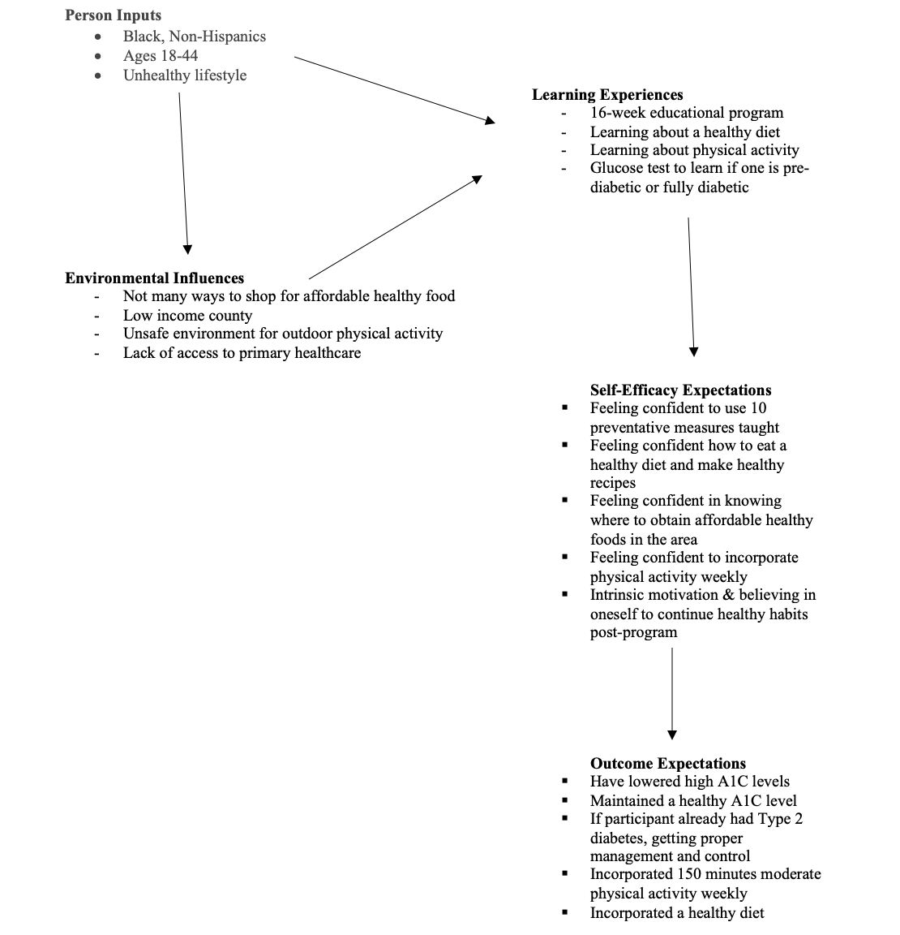

Objective  Type | Theory –  construct | Intervention  Strategy | Possible  Activities
Learning | SCT: Learning Experiences | Health Communication | · Public service announcements: creating a billboard for the area/ commercial/ads on social media  · Brochure on risks of diabetes placed in coffee shops, churches, libraries, gas stations, small department stores  ·
Environment | SCT-physical access and affordability | Health-related community service | · Outreach activities: Food banks offering healthier food choices and community gardens  · Provide free glucose testing  Community physical environment changes, such as building parks in safer areas for physical activity.
Behavioral | SCT: Self-Efficacy Skills | Health Education | · Use of effective self-efficacy skills to change their behavior  · Support groups to effectively reinforce lifestyle changes.

References
Tello, Monique. “Healthy Lifestyle Can Prevent Diabetes (and Even Reverse It).” Harvard
Health Blog, 6 Sept. 2018, www.health.harvard.edu/blog/healthy-lifestyle-can-prevent-diabetes-and-even-reverse-it-2018090514698.
Hicklin, T., Ph.D. (2018, January 23). Factors contributing to higher incidence of diabetes for
black Americans. Retrieved March 04, 2021, from https://www.nih.gov/news-events/nih-research-matters/factors-contributing-higher-incidence-diabetes-black-americans

